I started with figure number 2 and number 9 of the group 11. Here are these two images:

 

Figure - left: image 2 in group 11. Right: image 9 in group 11.

First, I cut ten pixels from each image at the merging border and tried to do morphing on them (actually nonrigind registration, because the morphing consists of two parts: nonrigid registration and intensity merging. We have done intensity merging, and I had to go for nonrigid registration).

Here I showed these two images that we obtain from the borders. (I rotated them 90 degrees to save space.)

C:\Users\Asus\Desktop\Imag1.tif

C:\Users\Asus\Desktop\Imag2.tif

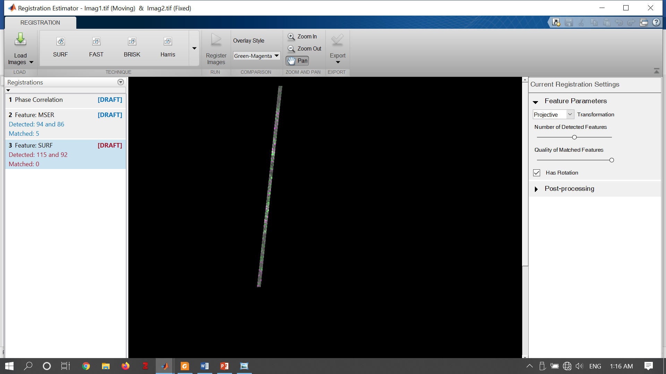

Figure - Up: Cut part of image2. Middle: Cut part of image 9. Bottom: Overlay of cut parts of image 2 and image 9.

We can see in the overlay image that there is a little intensity mismatch and a little structural mismatch in these two images.

Here are the results of nonrigid registration for (1) when image 1 is registered to image 2, and (2) where image 2 is registered to image 1 (again, both image rotated 90 degrees).





Figure - Up: nonrigid registration of image 2 to image 9. Bottom: nonrigid registration of image 9 to image 2.

Unfortunately, these images don’t match the other parts of our images. Figure 4 (up) shows the result of putting these images in the whole image. And in Figure 4 (bottom) I zoomed in our region of interest.





*Figure 4- Up: The result of merging image 2 and image 9. Bottom: The area in yellow box is zoomed for better visualization (90 degrees rotated).*

We can see that there are some mismatches specially at the borders. I tried to figure out why this happens. Here is what I think. Please consider Figure 5 (A, B), and assume they represent the border area that we have cut from our original images. I tried to simulate nonrigid registration in Figure 5 (C). We can see that a nonrigid registration can solve the mismatch problem in some regions, but at the same time causes problem in some other regions. Also, something that I couldn’t show in Figure 5(C) is that when we apply nonrigid registration, we shrink some parts of the image and dilate some other parts. The image acts like an elastic material. So, we exceed some parts of the border and go inward in some other borders (Figure 5 (D)). The areas that we go inward are filled with zeros (black pixels) that we can see examples of them in the areas in Figure 3 marked with yellow squares. These inward and outward shifts make some misalignments in our final result.

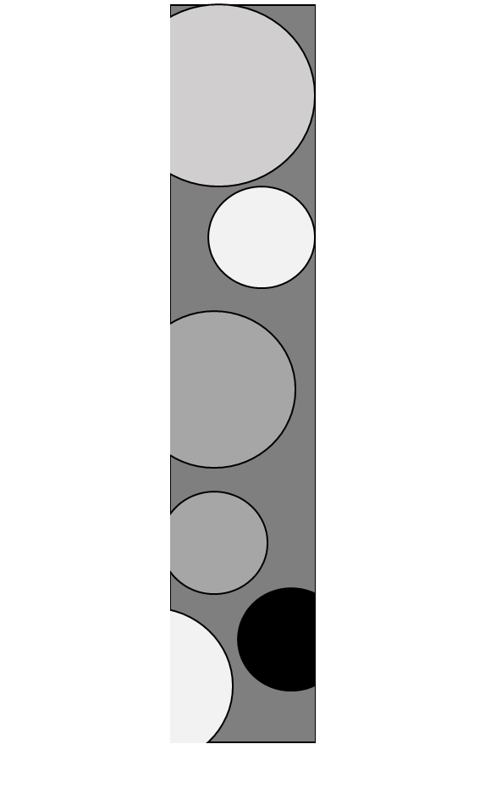 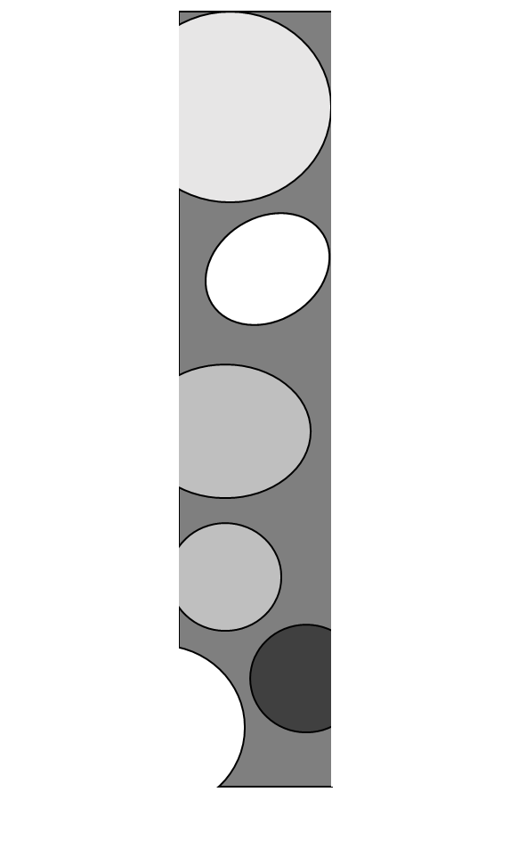 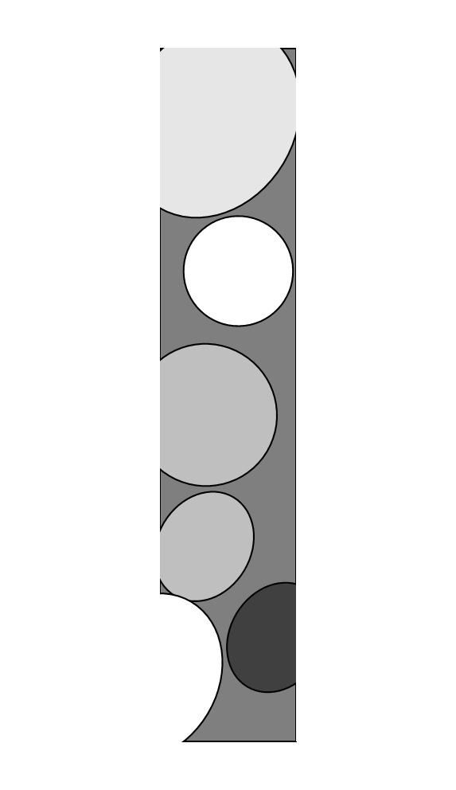 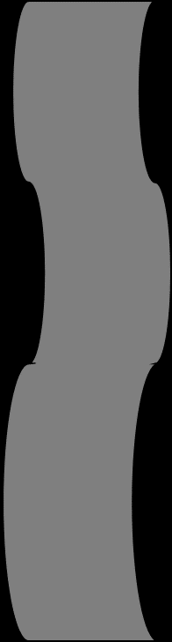

D

C

A

B

*Figure 5- A and B: two hypothetical picture considered as inputs for the nonrigid registration. (C) the hypothetical result of nonrigid registration. (D) a schematic of what happens at the borders.*

I tried to solve this problem by selecting a larger area from our input images. I mean I selected larger areas from image 2 and image 9, and applied nonrigid registration to them. Then, removed areas out of our targeted area and put the result in our final image. Figure 6 shows the selected parts of image 2 and image 9 and their overlay.







Figure - Up: Cut part of image2. Middle: Cut part of image 9. Bottom: Overlay of cut parts of image 2 and image 9.

Again, here are the results of nonrigid registration for (1) when image 1 is registered to image 2, and (2) where image 2 is registered to image 1.





Figure - Up: nonrigid registration of image 2 to image 9. Bottom: nonrigid registration of image 9 to image 2.

We can see that there is still some intensity mismatch between these images and between each of these registered images with the original images. But, if now we cut a narrow part of these images around the central line (showed in yellow in Figure 7 (bottom)), we have gotten rid of the problem around the borders. Then, I continued the process, and here is what I reached.





*Figure 8- Up: The result of merging image 2 and image 9. Bottom: The area in yellow box is zoomed for better visualization (90 degrees rotated).*

Unfortunately, the problem is not solved. When we apply nonrigid registration on one area of our images, it causes some misalignments between that area and the other parts of the image.

I think the ideal case was if could do a gradual nonrigid registration, same as gradual intensity alignment that we have already done. But, I think it is not possible. Here I explain why I think so. I thought maybe we can select a 1-pixel width line from the first image and the second image and find the transformation matrix that best matches these two lines. Then shift these lines by one pixel and repeat the process until the whole border area is covered. But since there is not a one-to-one relationship between the images it doesn’t work. For example, the area marked with red squares in Figure 7 are the same, but are not at the same position in our original images. However, this is the best position that automontaging algorithm finds for them. If we want to shift them (or apply any other rigid transformation on them), some other areas will be misaligned.

\*I put all images for the first part in folder “results1” and for the second part in folder “results 2”.